EPITHELIAL TISSUE

Epithelium is a sheet of cells that covers the external surface of any solid structure and the internal surface of any hollow tubular (e.g. lumen/cavities) structure. Thus it serves as a barrier membrane separating the underlying tissue from various external and internal environments.

CLASSIFICATION OF EPITHELIAL TISSUE
On the basis of the function(s) performed, epithelial tissue can be broadly classified into four types (see Flowchart 2.1).
Myoepithelium (e.g. myoepithelial cells)
Neuroepithelium (e.g. taste buds)
Glandular epithelium (e.g. glands)
Surface/lining epithelium
Broad classification of epithelial tissue

Functions:
Protection Absorption
Secretion Sensation Contraction

SURFACE (OR) LINING EPITHELIUM GENERAL FEATURES
- Epithelium, the ‘cellular sheet’, is made of either single layer or many layers of cells.
- Epithelial cells are adherent to each other by means of junctional complexes.
- Very little intercellular material is found between the cells.
- The deep surface (basal) of the epithelium rests on a basement membrane, which separates it from the vascular
connective tissue.
- Basement membrane (Fig. 2.1) is made up of
- basal lamina (amorphous substance) – product of epithelium
- reticular lamina (reticular fibers) – product of connective tissue.
- The superficial surface (apical) of the epithelium is free and exposed to air or fluid and often shows modifications (i.e. presence of microvilli or cilia) depending upon the function it is destined to perform.

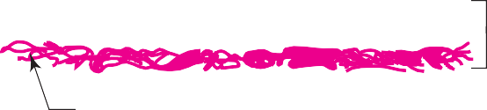
Basal lamina

Basement membrane

Reticular lamina

Fig. 2.1 Components of basement membrane.

- No blood vessels or lymphatics are found in the epithelium; nourishment is provided by diffusion from the adjacent supporting tissues.
- Epithelium has good regenerative capacity.
- Its nuclear shape corresponds to cell shape (nuclei are oval in columnar cells, round in cuboidal and polyhedral cells, and flat in squamous cells).
- Epithelium invaginates/infolds and subsequently grows in the underlying connective tissue, thus specialising as glands.
- Epithelium may undergo morphological and functional changes from one type to another type (metaplasia).
- Functions: Protection, absorption, secretion, excretion, lubrication, sensation and reproduction.
- Epithelium is derived from all three germ layers (skin – ectoderm; respiratory and digestive systems – endoderm; cardio- vascular system – mesoderm).

INTERCELLULAR JUNCTIONS (JUNCTIONAL COMPLEXES)
- Epithelial cells are adherent to one another by the binding action of the intercellular cell adhesion molecules (CAM) found in the interval between the plasma membranes of adjacent cells.
- The cell adhesion molecules are formed by glycoprotein and proteoglycan.
- The quality of intercellular adhesion is increased in those epithelial cells which are subjected to mechanical trauma (e.g.
skin).
In addition to this binding effect of CAM and ions, the plasma membrane of epithelial cells exhibit some specialisations that form intercellular junctions (junctional complexes). Following four junctional complexes are described below (Fig. 2.2):

Zonula occludens (tight junction)
- This junction is located near the apical part of the cell, where the outer surface of the plasma membrane of the cell fuses with that of the neighbouring cell, obliterating the intercellular space completely.
(e.g. intestine, urinary bladder).

Zonula adherens
- This junction is present immediately below the zonula occludens and its opposing plasma membranes are separated by a gap, 20 nm wide.

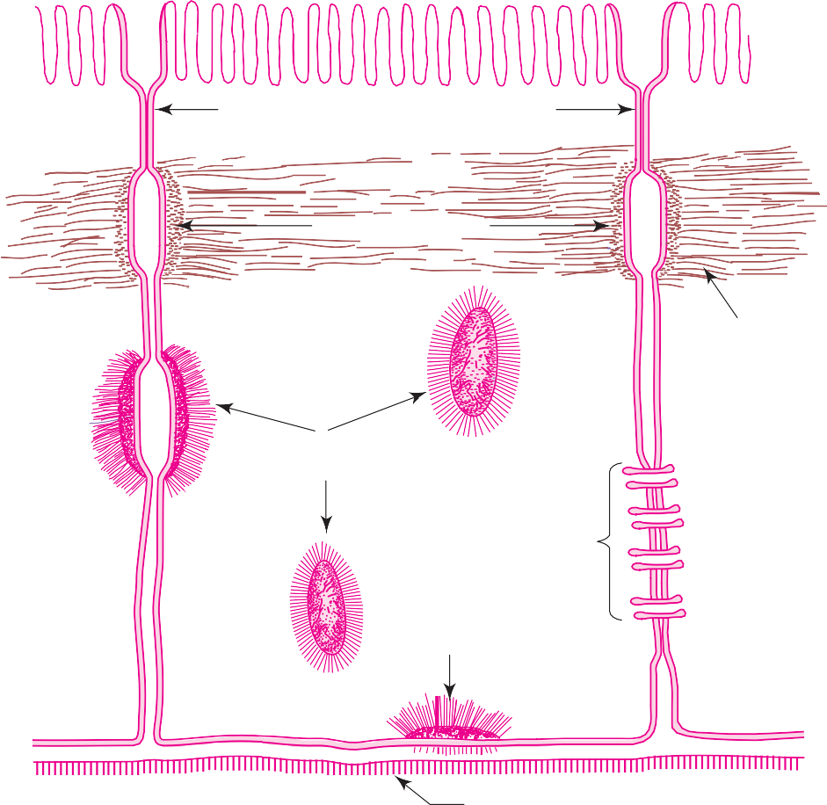
Zonula occludens (tight junction)

Terminal web

Zonula adherens
Microfilaments
Macula adherens (desmosome)
Gap junction (nexus)
Hemidesmosome
Basal lamina

Fig. 2.2 Intercellular junctions (junctional complexes).

Macula adherens (desmosome) and hemidesmosome
- Desmosomes are the third component of junctional complexes.
- They are scattered over the lateral surfaces of epithelial cells in the form of discs.
- The opposing plasma membranes are separated from each other by a gap of 30 nm and is bridged by transmembrane proteins. (e.g. epidermis of skin).
- Hemidesmosomes are half desmosomes found on the basal surface of the epithelial cell binding it to the subjacent basal lamina.

Gap junction (nexus)
- Gap junction is seen on the lateral surface of the epithelial cells, where adjacent plasma membranes are closely apposed.
- Each junction contains numerous transmembrane protein channels (connections) that permit the passage of inorganic ions and other small molecules from the cytoplasm of one cell to another.

SURFACE MODIFICATIONS OF EPITHELIAL CELLS
- Luminal surface of epithelial cells may be modified to perform specific functions, viz. glycocalyx, microvilli, stereocilia and cilia.
- The different modifications and the role played by them are enumerated in Table 2.1.

Table 2.1 Surface modifications of epithelial cells

Surface modifications Functions

  - Glycocalyx (cell coat/ fuzzy coat)

  - Microvilli (brush border/ striated border)

  - Stereocilia

  - Cilia
- Glycocalyx is a surface coat over the absorptive epithelium of small intestine. It is rich in polysaccharides and also contains proteins and hydrolytic enzymes
- Acts as receptor sites for hormones and enzymes

- Microvilli are minute finger-like projections of the plasma membrane (see Table 2.2)
- Increase the surface area for absorption (intestine)
- Transport the absorbed material (by the microfilaments in the central core)
- Participate in the digestion of carbohydrates
- Stereocilia are very long, thick microvilli, nonmotile, may show branching
- Increase the surface area for absorption (epididymis)
- Help perception of stimuli (internal ear)
- Cilia are long hair-like projections of plasma membrane (see Table 2.2)
- Beat towards one direction, thereby moving the entangled particles from the surface (beat towards pharynx in respiratory tract and towards uterus in uterine tube)

Table 2.2 Differences between microvilli and cilia

Microvilli Cilia

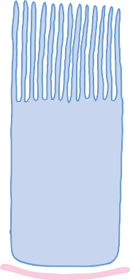
Cilia
Microvilli

Diagram

Microfilaments

Peripheral microtubules

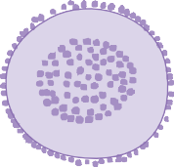
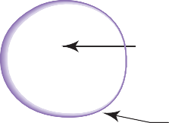
C.S. of microvillus Basement membrane
Glycocalyx

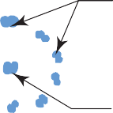
C.S. of cilium

Basement membrane
Central microtubules

Columnar Cell with Microvilli Columnar Ciliated Cell
Length 0.5–1.0 µm 5–10 µm
Diameter 0.1 µm 0.2 µm
Motility Nonmotile Motile
Central core Contain microfilaments 9 + 2 Pattern of microtubules
Functions Absorption Driving the entangled particles: transport in one direction

Example Intestinal epithelium, proximal convoluted tubules of the kidney

CLASSIFICATION OF LINING EPITHELIUM
Respiratory tract, uterine tube, ependyma

Epithelium is classified based on the number of cell layers and the shape of the cells on the free surface (Table 2.3). Characteristics of each type of epithelium are described in the practical section.

Table 2.3 Classification of lining epithelium

Based on cell layer Based on cell shape Occurrence Functions

A. SIMPLE (S.)
One layer
(Box 2.1, Box 2.2)

S. Squamous
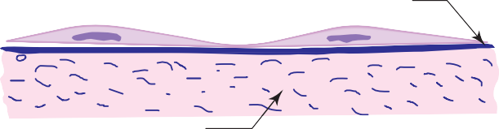
Cells are flat plates

Lamina propria (connective tissue)

S. Cuboidal

Basement membrane
- Endothelium (lining of blood vessels)
- Mesothelium (lining of body cavities)
- Lung alveolus
- Parietal layer of Bow- man’s capsule

- Thyroid follicles
- Active transport by pinocytosis

- Secretion

Cells have same height and width
  - Kidney tubules
  - Pigmented layer of retina
  - Germinal layer of ovary

Lamina propria Basement membrane

S. Columnar (nonciliated)
Cells are tall, column-like

- Stomach
- Intestine
- Gall bladder

  - Absorption
  - Secretion

Capillary

S. Columnar (ciliated)

Lamina propria
Basement membrane

- Uterine tube

  - Transport

Cells are tall, column-like and with cilia
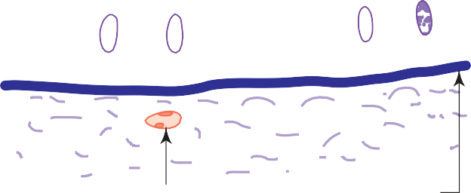
Cilia
    - Secretion

Lamina propria

Capillary
Basement membrane

(Contd.)

Table 2.3 (Contd.)

Based on cell layer Based on cell shape Occurrence Functions

B. PSEUDO- STRATIFIED
False stratification
(Box 2.3)

Pseudostratified
Columnar (ciliated)
- Nasal cavity
- Trachea
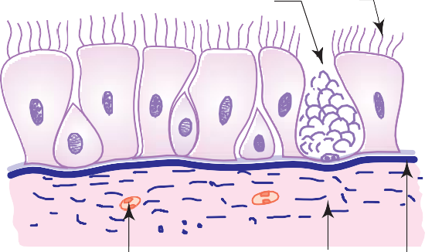
- Bronchi
Goblet cell
Cilia
  - Transport
  - Protection
  - Secretion

C. STRATIFIED (Str.)
More than one layer (Box 2.4 to Box 2.6)

Capillary Lamina
propria

Pseudostratified
Columnar (with stereocilia)

Str. Squamous
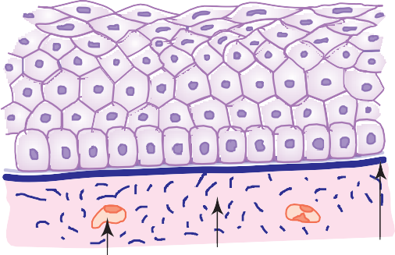
Nonkeratinized

Basement membrane

- Epididymis
- Vas deferens

- Mouth cavity
- Oesophagus
- Vagina
- Anal canal

  - Protection
  - Secretion
  - Absorption
  - Protection

Capillary Lamina propria
Keratinized
Basement membrane

  - Epidermis

    - Protection

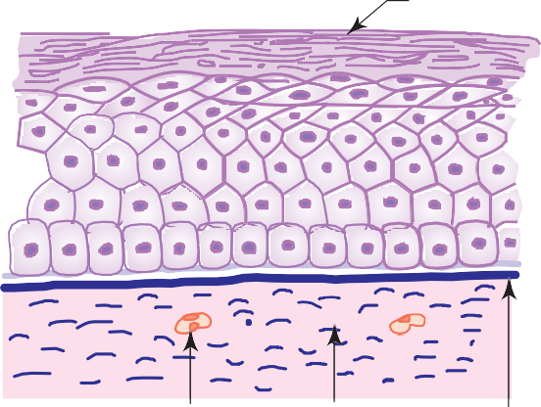
Capillary Lamina propria
Keratin

Basement membrane

(Contd.)

Table 2.3 (Contd.)

Based on cell layer Based on cell shape Occurrence Functions

Str. Cuboidal
      - Sweat ducts
- Protection

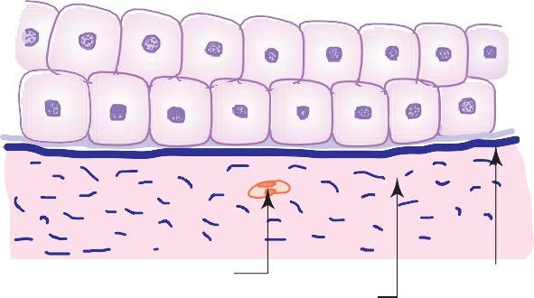
Capillary

Lamina propria

Basement membrane

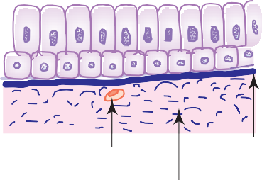
Str. Columnar
  - Palpebral conjunctiva
- Protection

Capillary

Lamina propria
Basement membrane

Transitional (urothelium)
  - Ureter
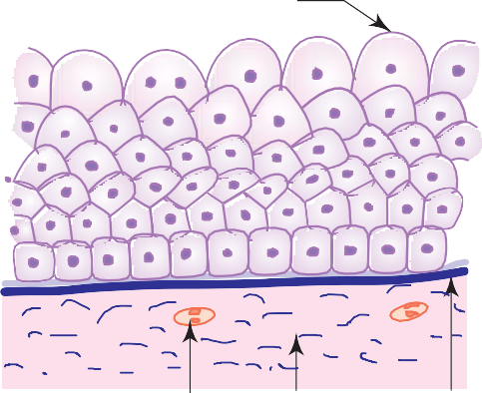
  - Urinary bladder
Facet cell
- Protection

Capillary
Lamina propria
Basement membrane

Buccal Smear.

Squamous Epithelial Cell

Nucleus

Dweecn uogct
Box 2.1
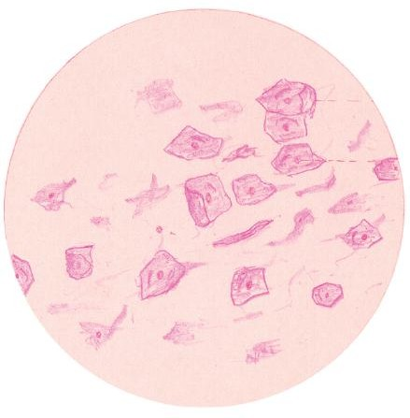
Presence of
- flat polygonal cells with centrally placed spherical nucleus.

Cuboidal Epithelium.

Collecting Duct Lined by Cuboidal Epithelium

Interstitial Connective Tissue

Capillary

Ewdqifcn grivjgniwo. g0i0 collecting duct of kidney
Box 2.2
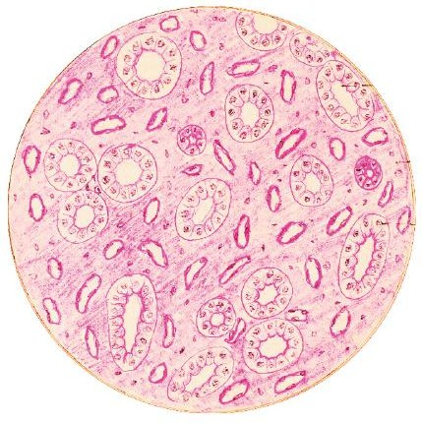
Presence of
(i) cuboidal cells with centrally placed round nucleus.

Box 2.3
Pseudostratified Ciliated Columnar Epithelium.
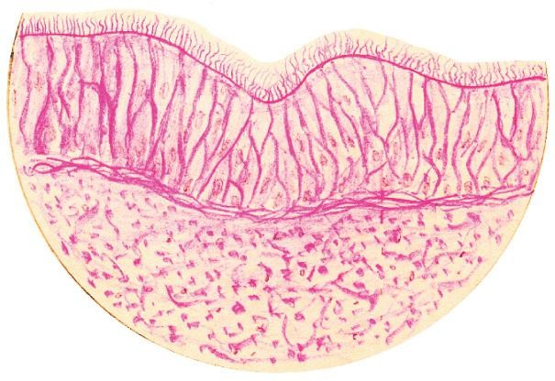
Presence of

Cilia Goblet Cell
Columnar Cell

Basement Membrane Basal Cell
Lamina Propria

Rugwfquvtcvihigf einicvgf eqnwopct grivjgniwo. g0i0 trachea
- cells of different shapes and height lying on basement membrane;
- hair-like processes (cilia) on the free surface of the epithelium.

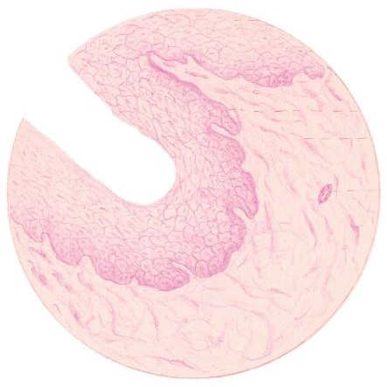
Presence of

Squamous Cells Stratified Polyhedral Cells Squamous
Epithelium
Columnar Cells
Basement Membrane Lamina Propria

Arteriole

Uvtcvihigf uswcoqwu grivjgniwo. g0i0 oesophagus
Box 2.4
Stratified Squamous Epithelium.
- many layers of cells;
- flat cells (squamous) with elliptical nuclei in the superficial layer.

Box 2.5
Stratified Squamous Keratinized Epithelium.
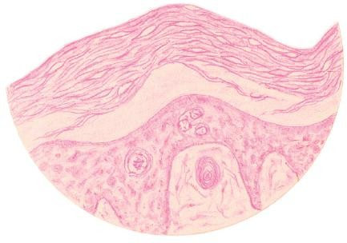
Presence of

Keratin

Cells of the Malpighian Layer

Basement Membrane

Uvtcvihigf uswcoqwu mgtcvipi|gf grivjgniwo. g0i0 epidermis
- many layers of cells;
- dead flat scaly cells in the superficial zone (stratum corneum).

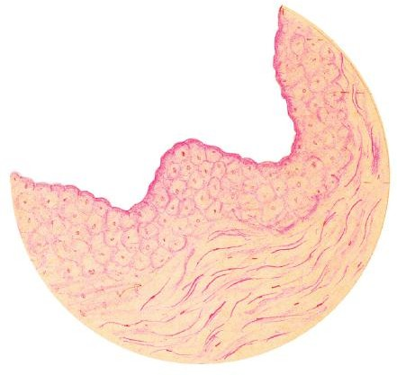
Presence of

Doom-Shaped Facet Cell

Transitional Epithelium

Lamina Propria

Vtcpuiviqpcn grivjgniwo. g0i0 urinary bladder
Box 2.6
Transitional Epithelium.
- many layers of cells of varying shape;
- cells of superficial layer—are large and umbrella-shaped giving a scalloped margin to the luminal surface of the epithelium;
- cells of deeper layers—are small and so their nuclei are situated close to one another.

SOME BIOLOGICAL PHENOMENA OF THE CELL
Cells are the functional building units of all living organisms. Mammalian cells exhibit a wide range of morphological and functional specializations to suit their external and internal environment. Study of the cell by means of electron microscope gives a lot of information about its ultrastructure and its organelles. With the use of modern techniques like electromicroscopy, autoradiography and immunohistochemical staining, the functional activities of the cells are better understood.

Exocytosis
Exocytosis is the process by which synthesized molecules and other substances leave the cell. This process is associated with the fusion of vesicles containing synthesized materials with the plasma membrane and liberating their contents to the extracellular space, e.g. merocrine secretion of glands (Fig. 2.3). The membrane that is added to the plasma membrane by exocytosis is recovered into the cytoplasm by endocytosis and re-used by membrane bound organelles, as well as membrane lost or damaged during normal metabolic activities of the cell.

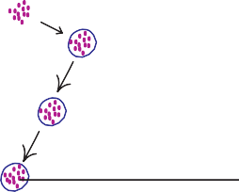
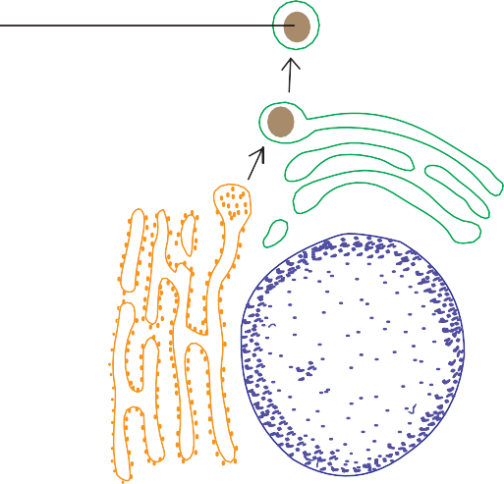
Exocytosis Pinocytosis

Secretory granule

Golgi apparatus
Pinocytotic vesicle

Mitochondria

Nucleus
rER

Endocytosis
Fig. 2.3 Exocytosis and pinocytosis.

Endocytosis is the process by which either small or large molecules enter the cell via vesicles formed from the plasma membrane. Both pinocytosis and phagocytosis fall under this category.

Pinocytosis (Gr. Cell Drinking)
Pinocytosis is the process by which extracellular interstitial fluid and small protein molecules are taken into the cell via small vesicles which are pinched off from plasma membrane. These vesicles are less than 150 nm in diameter. Though pinocytosis is performed by virtually every cell, these vesicles are especially numerous in the enodothelium of blood vessels and in smooth muscle cells.
Substances to be pinocytosed first make contact with the extracellular surface of the plasma membrane, then the surface becomes indented and finally the invaginated portion pinches off from the membrane to become a pinocytotic vesicle within the cell (Fig. 2.3).
The capillary endothelium is involved in transporting nutrients and oxygen from the blood plasma through pinocytotic vesicles into the interstitial fluid. In the same way, interstitial fluid containing dissolved carbon dioxide is also taken up by pinocytosis for transportation across the endothelial cell wall in the opposite direction. It takes about 2–3 minutes for the pinocytotic vesicles to cross the wall.

Phagocytosis (Gr. Cell Eating)
Phagocytosis is the process by which large particles such as cell debris, bacteria and other foreign materials are ingested into the cell through large vesicles called phagosomes. Phagocytosis is generally a receptor mediated process performed by a specialized group of cells belonging to the mononuclear phagocytic system.
During phagocytosis, phagocytic cells put forth cytoplasmic processes called pseudopodia that surround and engulf the foreign particle forming a phagosome or endocytotic vesicle. This vesicle detaches from the plasma membrane and is found free in the cytoplasm. The phagosome then fuses with the primary lysosome to form a secondary lysosome (Fig. 2.4). Lysosomal

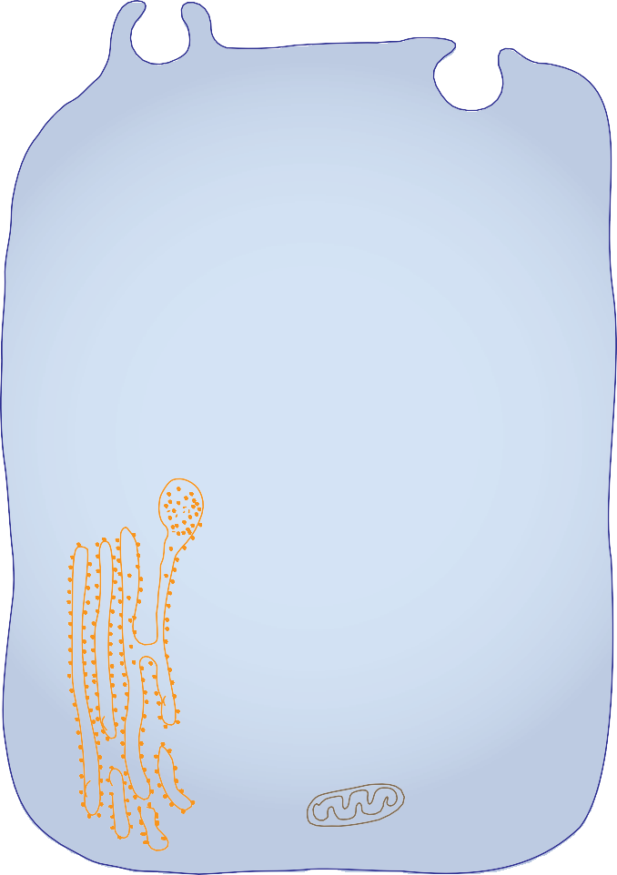
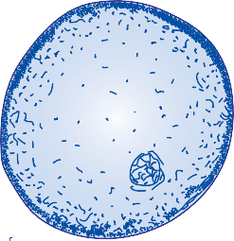
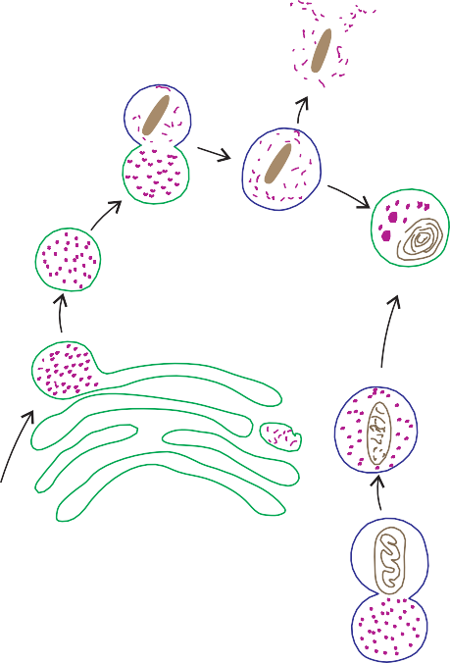
Fig. 2.4 Phagocytosis.
Phagosome
Primary lysosome
Secondary lysosome
Residual body
Golgi apparatus
Nucleus
Autophagosome
Mitochondrium
rER

enzymes digest the engulfed material. When the digestion is complete, lysosomal membrane may rupture, discharging its contents into the cytoplasm. Undigested material may remain within the membrane-bound vesicles called residual bodies, the contents of which may be discharged at the cell surface by exocytosis or with advancing age they may accumulate in the cytoplasm and appear as brown lipofuscin granules (age pigments).
Lysosomes are also involved in digestion of aged or worn out organelles, a process known as autophagy (Fig. 2.4). The products of degradation are re-utilised by the cell for metabolic processes.

